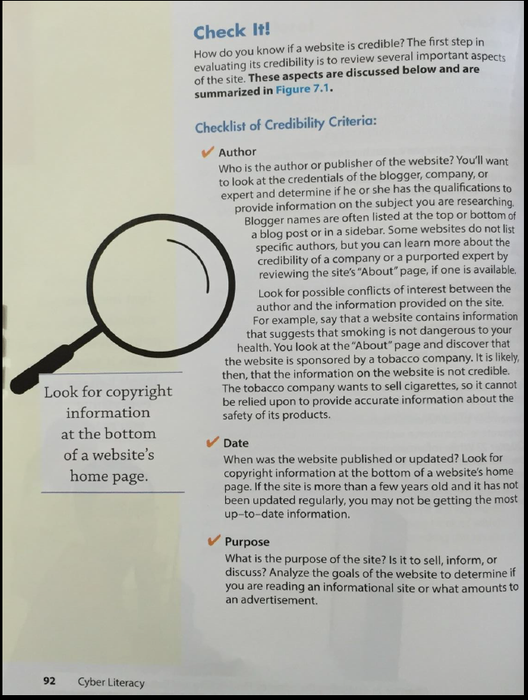

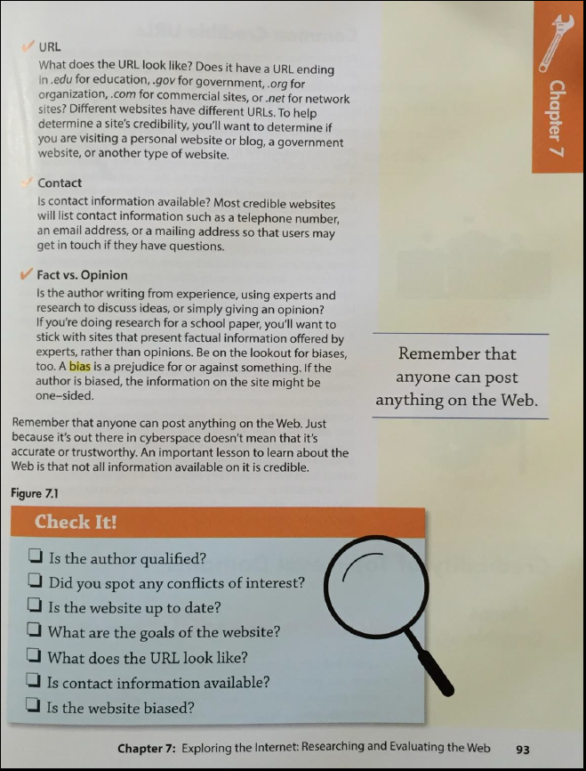
Questions | Answer
A credible source needs to come from a credible site. You need to know what each site stands for. One way you can do this is but knowing the URL ending. What do the following URL endings stand for?
.edu
.gov
.org
.com
.net
Under Contact: What do most credible websites list on their web page?

