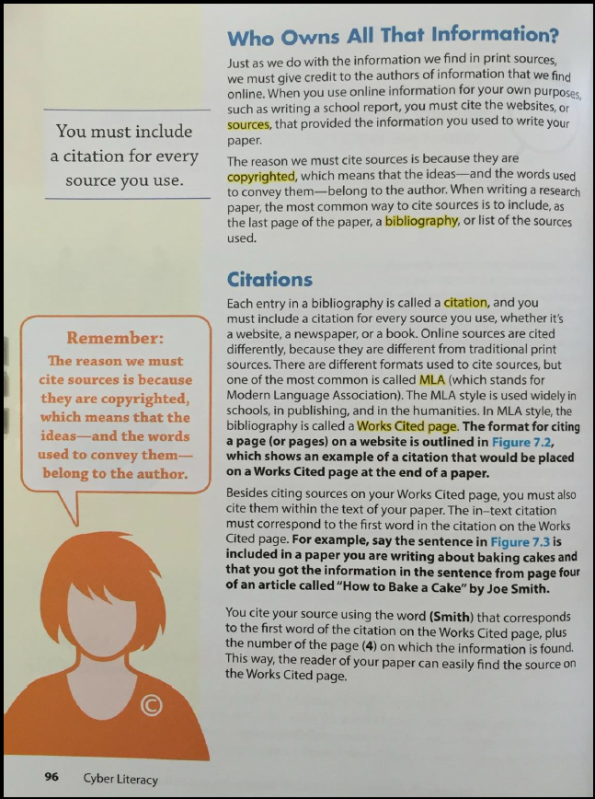

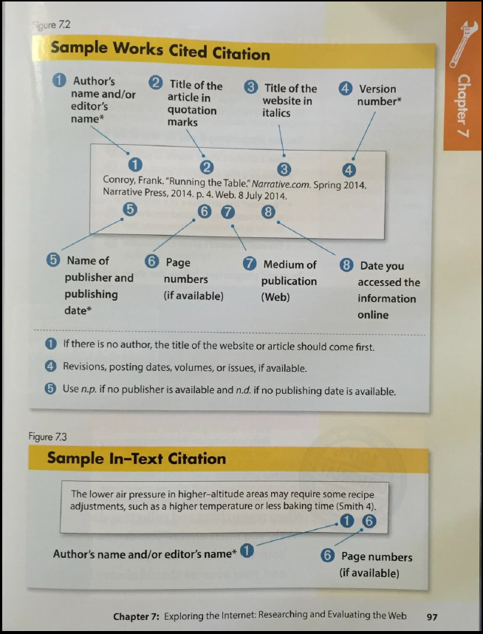

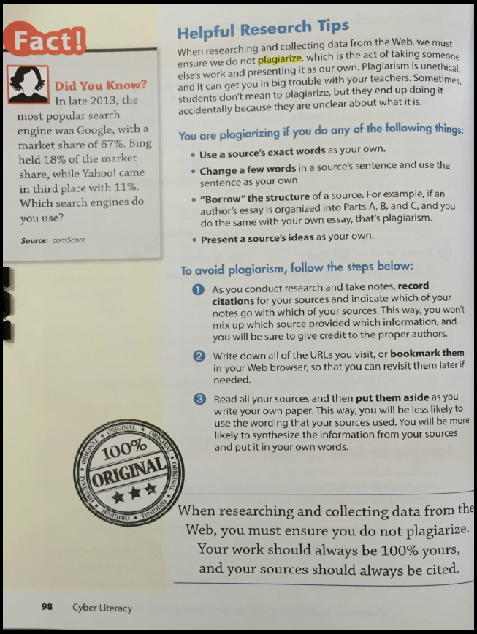
Questions | Answers
Why do you have to site sources from the internet?
What is the bibliography?
List the 8 items that should be listed in a works cited:

