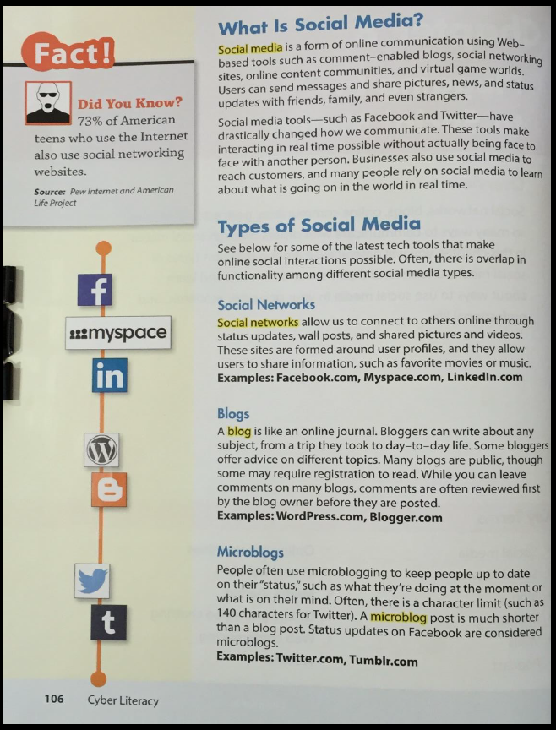

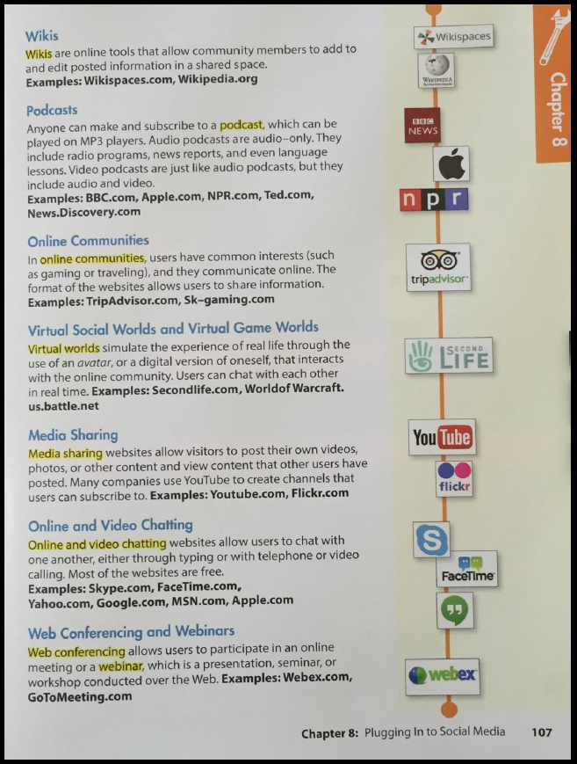
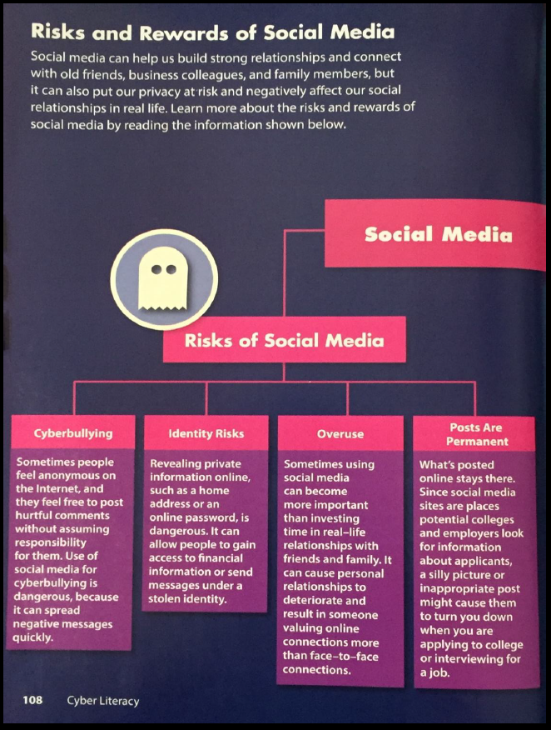
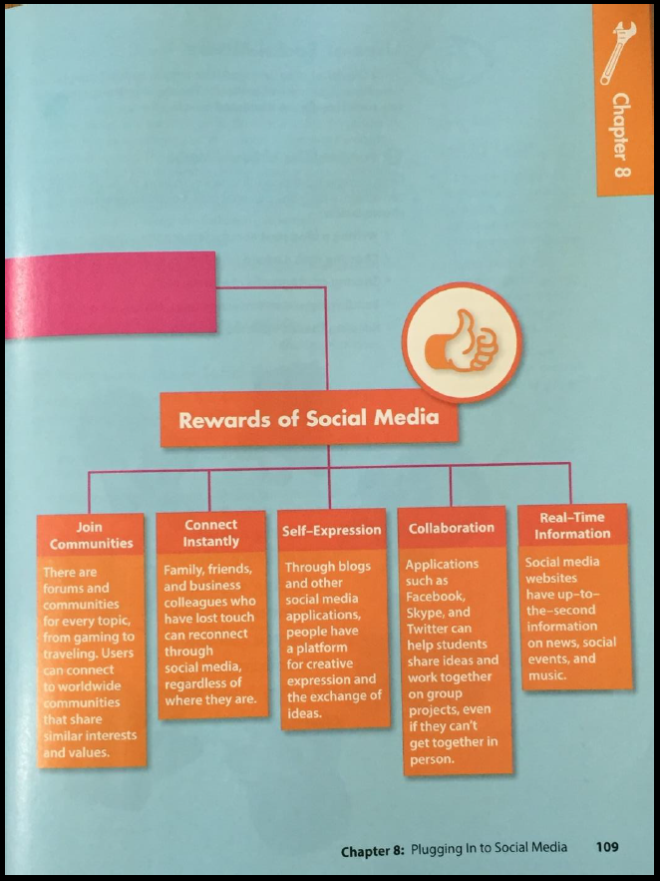

Questions | Answers
What is social media?
What’s a blog?
What is web conferencing?
What are the 4 risks of social media identified in the article?

What are the 5 rewards of social media identified in the article?

