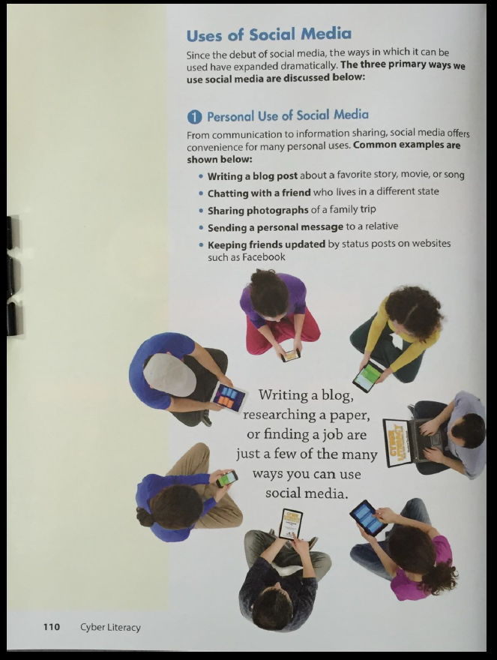

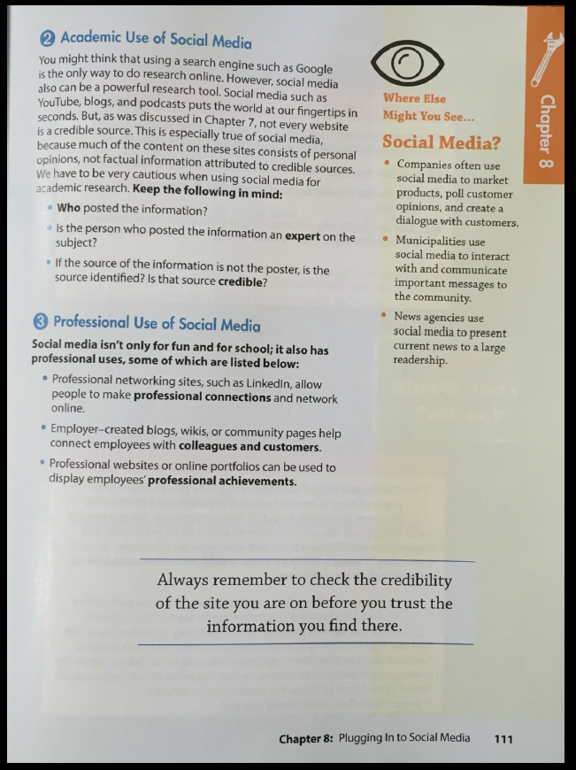
Questions | Answers
What are 5 common examples of how social media is used?
List three ways that social media is used for Professional uses.

