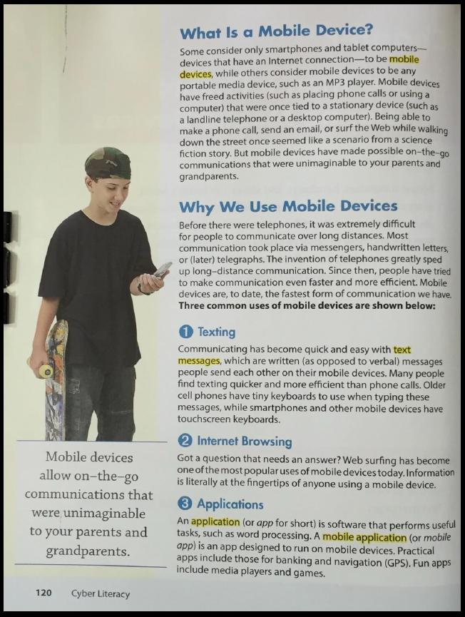
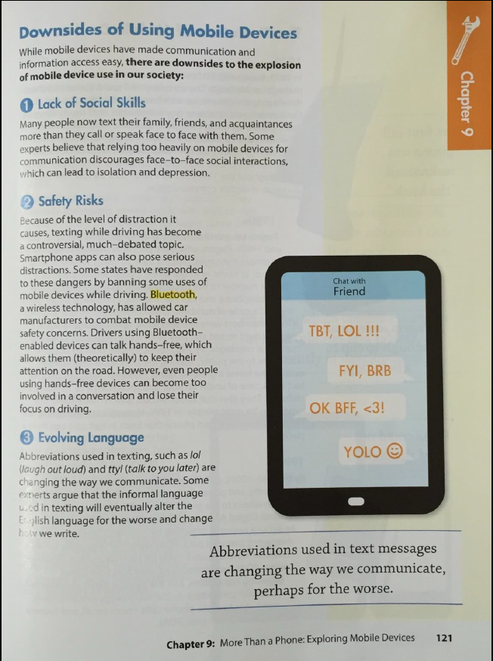
Questions | Answers
What are the three common uses of mobile devices?
How do you use your device?
What are the three downsides to the overuse of mobile devices in our society?

