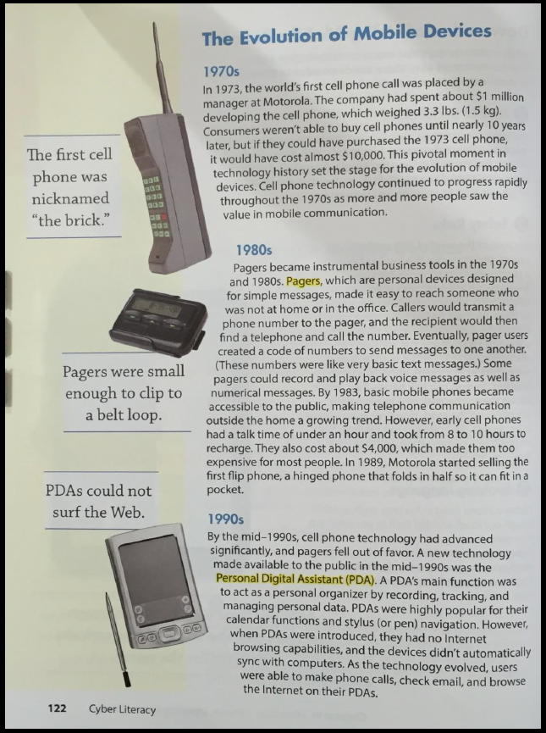
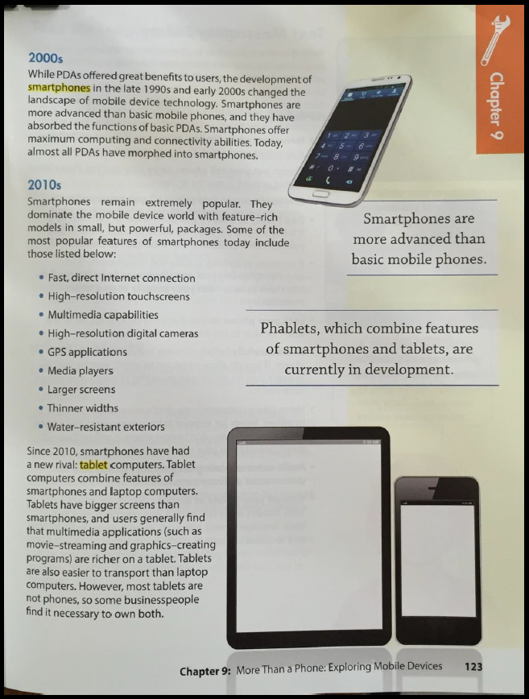
Questions | Answers
Mobile Devices have been around for several years. Describe each decade and what devices dominated during that time.
1970s
1980s
1990s
2000s
2010s
What device do you think will dominate in the 2020s?

